REQUEST FOR PROPOSAL
Geothermal Services
Head Start Operation Center,
1433 Bacharach Blvd. Atlantic City, NJ
Client: Gateway Community Action Partnership

PROPOSAL PARAMATERS AND GUIDELINES

- Submission Requirements. All proposals must be presented in accordance with the requirements, format, and guidelines described in this Request for Proposal (RFP) document.

- Submission Deadline. Interested entities must submit (3) copies of proposals no later than 4:30 p.m., Wednesday, July 30, 2014. Submittals should be addressed and delivered to:

Edward Bethea, Sr. Vice President/Chief Operating Officer Gateway Community Action Partnership
110 Cohansey Street 08302
(856) 451-6330, Ext. 6655

- Interpretation and Addenda. All questions, requests for interpretation, and comments shall be prepared in writing and submitted to Steven Caputo (scaputo@gatewaycap.org) and Daniel Muller (dtmuller@gatewaycap.org) via email by July 24, 2014. Question and clarification responses will be sent to all parties having submitted questions. All responses will be binding. If a respondent has no questions please state so via email so that responses will be forwarded. Oral and other interpretations will be without legal effect.

OVERVIEW

Gateway Community Action Partnership’s interest is in the vacant building located at 1433 Bacharach Blvd., Atlantic City, NJ Block 293/Lot 1, currently owned by Atlantic County. Gateway believes this site can be turned into an Early Head Start/Head Start center for Atlantic City families. Because this site is situated between AtlantiCare, the library, county and city governmental offices, churches, and a community college, as well as the only supermarket in town, it is an ideal location for our Head Start Program.

REQUEST FOR PROPOSAL

This RFP is issued by Gateway Community Action Partnership (GCAP), a 501 (c) (3) tax exempt nonprofit corporation.

ROLE OF THE DESIGNATED ENGINEER

The designated engineer will work closely with GCAP staff on an as-needed basis to provide services related to a development project at 1433 Bacharach Boulevard in Atlantic City, New Jersey, Block 293, Lot 1. The project entails complete demolition and new construction. An approximate 62,000 square foot structure is envisioned, with five levels from the ground up. An elevated structure may be needed to satisfy FEMA flood regulations, as the site is three blocks from the shoreline and is in a flood zone.

The entire parcel of land is 15,290 square feet in size. See Appendix A.

Following the RFP submission, the selected engineer will work closely with GCAP staff, Board, and General Counsel to ensure consistency with overall operating guidelines and requirements of Gateway CAP.

RFP SUBMISSION REQUIREMENTS

Respondent’s submissions must include the following core components, in order to be considered responsive to this solicitation:

- A current client list for related projects
- A fee schedule(s) showing billing rates for the various categories of employees employed by the Engineer and a schedule of the reimbursable expenses is to be included with the proposal submittal. Cost proposals or cost estimates are required at this time. All estimates should be based on Prevailing Wages.
- The Engineer’s Business Registration & Insurance Certificate.

CONDITIONS FOR SUBMISSION OF PROPOSAL

All proposals in response to this request must meet the following conditions to be considered:

- 3 copies of the submission: 8.5x11 format; 11x17 fold-outs are permitted
- Breakdown the proposal by the steps of work necessary
- Proposals must be received by the date and time specified; late proposals will be disqualified.
- In order to be considered for selection, applicants must submit a complete proposal. Incomplete proposals may not be considered.
- Proposals must include a Cover Sheet or Letter clearly stating the name of the applicant, address and telephone number of the applicant representative.

The funding award for these services and project shall be made at the sole discretion of the Gateway Community Action Partnership Board of Directors. Gateway Community Action Partnership is under no obligation to select any presented proposals. Funding is subject to all necessary approvals by Federal, State and local agencies and their representatives. GCAP reserves the right to request additional information from all applicants. GCAP reserves the right and anticipates inviting top respondents to engage in an interview process to obtain additional information that will be used during the selection process. GCAP reserves the right to reject any and all proposals submitted, and to negotiate portions thereof.

APPLICATION RANKING CRITERIA.

All submissions shall be initially reviewed to determine if they are responsive to the submission requirements. Those not meeting the minimum requirements set forth herein will be deemed non-responsive, and will not be subject to further review.

The responsive submissions shall be evaluated and ranked in accordance with the scoring criteria, based upon a 25-point system.

5 points – Previous history, working with non-profits and government agencies and your direct experience with Head Start, childcare and commercial projects.

10 points – Overall professional Proposal, experience, proven capacity of the organization and its key personnel and staff

10 points – Timeliness of projected completed date and overall cost estimate

CERTIFICATION FORM NOTE

THIS PAGE MUST BE COMPLETED AND INCLUDED WITH THE SUBMITTAL CERTIFICATION
The undersigned hereby certifies, on behalf of the Respondent named in this Certification (the “Respondent”), that the information provided in this RFP submittal to ISSUER is accurate and complete, and I am duly authorized to submit same. I hereby certify that the Respondent has reviewed this RFP in its entirety and accepts its terms and conditions.

______________________________________________
(Name of Respondent)

______________________________________________
(Signature of Authorized Representative

______________________________________________
(Typed Name of Authorized Representative)

______________________________________________
(Title)

______________________________________________
(Date)
APPENDIX A:
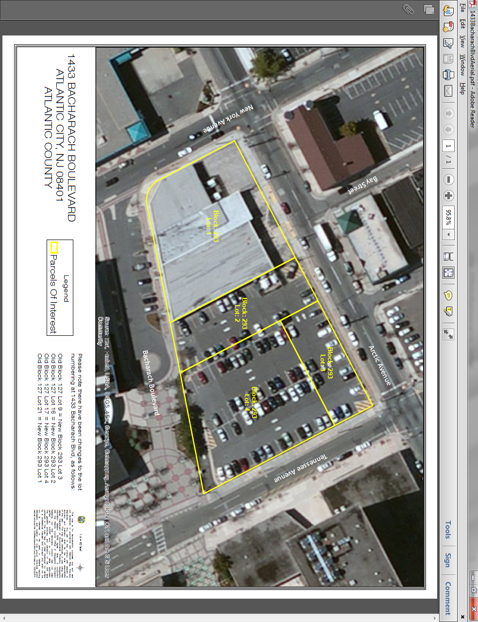
APPENDIX B: Geothermal Investigation Specifications
- The Engineer shall submit a proposal for making Test Borings and preparing a report including, but not limited to, the following:
        - The proposed drill depth for the geothermal test bore at 500 feet.
        - The loop size pipe diameter for drill depth of between 400-500 feet deep will be 1 ¼ inch loop pipe.
        - Grout conductivity – To be standard bentonite grout specified
        - Thermal conductivity test duration. A minimum of 40 hours is required, with a maximum of 48 hours.
        - Availability to perform the job.
        - Lead time for turnaround results.

